## Oct 2, 2024 | Insync Meeting 6 | Sprint Retrospective

Attendees:

Justin Zhang, Aditya Borkar, Gowrisankar Palanickal, Ananya Subramaniam, Sahasra Yellapragada

Notes:

* + Finished wireframes
  + Basic html pages
  + Tentatively decided on using firebase to implement chat functionality
  + Added club admin for the sitemap
  + Tentatively decided on using google calendar api
  + 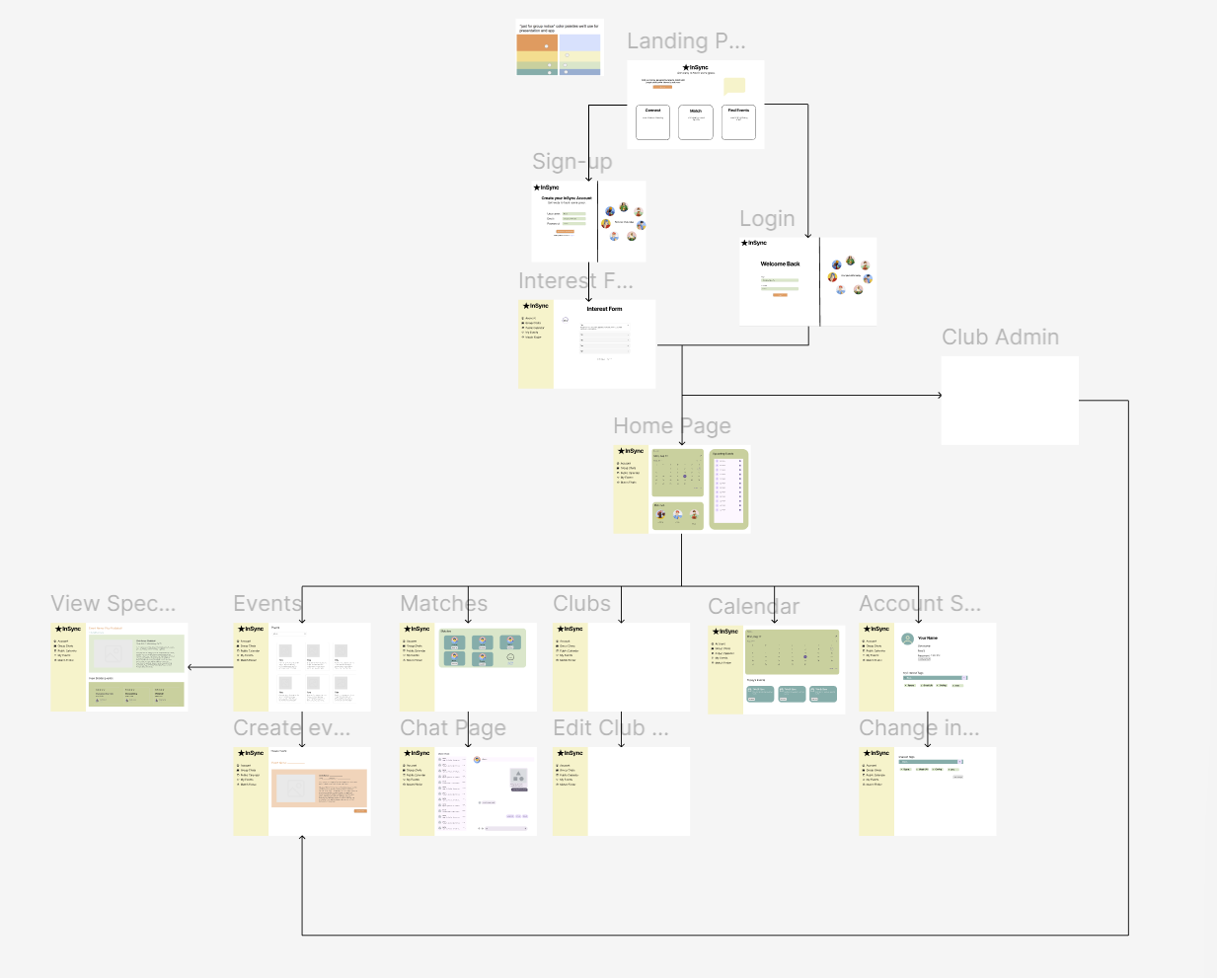

Ananya:

1. What did you like about this sprint? We were able to finalize our basic HTML pages, our sitemap, CSS and design, and our databases. This allows us to have a solid foundation for the rest of our project because we can continue to build off of that framework.
2. What did you learn this sprint? In this sprint, I learned how to manage my time and work with a team on a schedule. By collaborating with my group, I better understand how to accomplish deadlines together.
3. What did you lack this sprint? I lacked some technical understanding in this sprint. Since I wasn't doing much of the backend, I will focus more on actual coding for the next sprint.
4. What one thing can you do to make the next sprint better? One thing I can do to make the next sprint better is to start working on the Chat APIs so that function can be running before we try to design it better.
5. What can I do to help, if anything? Nothing right now! Thank you!

Aditya:

What did you like about this sprint?

All of our basic HTML pages have been completed, our sitemap and CSS have been finalized, and all of the databases have been set up.

What did you learn this sprint?

In this sprint I learnt how to manage and separate databases. I’m lucky to also be taking Database systems, so I was taught how to ensure that there would be no redundancy. I made sure to also include every piece of data that we would want to keep track of.

What did you lack this sprint?

I lacked the motivation to really get started, and I kept putting off the work until the very last second. Obviously, I need to change this going forward. However, I am in charge of the MySQL and PHP, so I should have more fun going forward

What one thing can you do to make the next sprint better?

Focus more on improving the databases and break down my main goal into smaller pieces to make the process of creating the website not overwhelming.

What can I do to help, if anything?

I haven’t really needed much help so far, but I will be sure to ask if anything pops up. I will probably need help staying on track, but that is more a problem for me than for Dr. C

Shankar:

1. What did you like about this sprint?
   1. I liked that we were able to get most of our planning (sitemap, IA, etc.) done and basic html/css, and database set up
2. What did you learn this sprint?
   1. I learned how we could implement calendar APIs to create calendar functionality on our web app
   2. I began reading the documentation for calendar APIs such as the Google Calendar API and the Outlook calendar API
3. What did you lack this sprint?
   1. I definitely lacked some motivation to begin working
   2. I didn’t have a full understanding of how to properly implement and use APIs towards the start of the sprint
4. What one thing can you do to make the next sprint better?
   1. I definitely need to get a start on implementing the calendar so I don’t rush toward the end of the next sprint and run into problems
5. What can I do to help, if anything?
   1. Nothing as of right now, but you can continue to help answer any questions we have

Justin:

1. What did you like about this sprint?
   1. One thing I liked about this sprint is that we established the baseline of what everyone has to do and is a good starting point for the upcoming sprints. We established what technologies we would use for the backend and completed the front-end design of the project.
2. What did you learn this sprint?
   1. This sprint, I learned that it was important to have good communication between team members and the basic organization of sprints, scrum meetings and experiencing proper git workflow for the first time.
3. What did you lack this sprint?
   1. This sprint, I think I lacked actually implementing the designs that we have created and sometimes put off assignments.
4. What one thing can you do to make the next sprint better?
   1. One thing I can do to make the next sprint better is to stay on top of what I was in charge of and working more consistently.
5. What can I do to help, if anything?
   1. I think we got it!

Sahasra:

1. What did you like about this sprint?
   1. We got all of our basic html pages done, finalized our sitemap, css (including our colors for the website), and decided on what tables we needed to use.
2. What did you learn this sprint?
   1. I learned that there are so many details that we need to finalize so I’m glad we got to make those decisions now. I also learned that it takes a lot of coordination to work as a group. I also learned how to use Figma.
3. What did you lack this sprint?
   1. I think in this sprint I lacked coding. I worked on the wireframes so I wasn’t able to code anything yet. I’m hoping to contribute more coding wise during the next sprint.
4. What one thing can you do to make the next sprint better?
   1. I’m hoping to stay more organized so I can get more done and be able to contribute more throughout the week. I’ll start working a little by little each day to lighten the load.
5. What can I do to help, if anything?
   1. Not currently